React JS as well as Angular Framework help to develop SPA (Single page application).

**Multi Page Application Vs Single Page Application**

Index.html welcome.html

<a href=”welcome.html”>click</a>

In Single page application we load only part of the web page contents rather than whole web page.

React JS is a library which help to create SPA application. React use function concept which is use to create the **components**. **Component** is use to control the view or part of the view page.

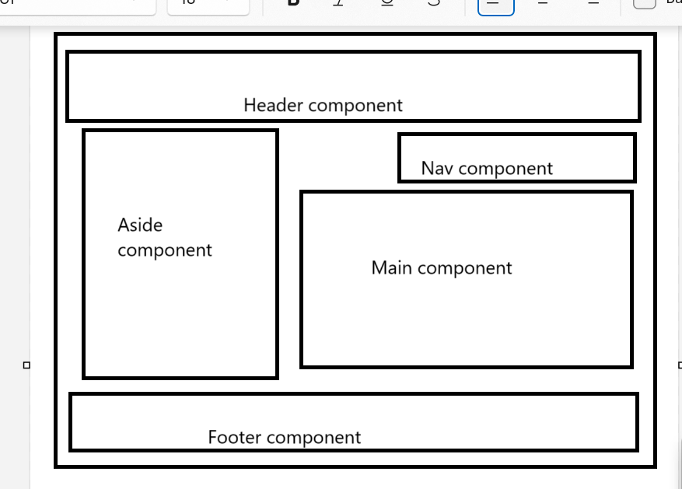

**Node JS :** Node js is known as server side scripting language. Before node js we were depending upon other programming language to develop backend technologies like java (spring boot), python with Django / flask, asp.net, php etc.

But after node js JavaScript also known as client side as well as server scripting language.

Node JS software provide us npm or npx tools which help to create react or angular or vue js project.

Using npm we are installing external module ie create-react-app which help to create the project.

Check node js software using terminal

node --version

npm install create-react-app -g

create-react-app my-react-app

cd my-react-app

open this project in VS Code editor

npm start in terminal

<http://localhost:3000>

react component contains 2 type of variable

1. State variable : which is use to describe the component behaviour
2. Props variable : it is use to pass the value from one component to another component.